Mason Middle School
Wrestling
2022
Day Date Opponents Place Time Bus Leaves
Tues. 1/25 Portland, Holt, Eaton Eaton Rapids 4:30 p.m. 2:45 p.m.
Rapids
Tues. 2/1 Fowlerville, Williamston Fowlerville 4:30 p.m. 3:00 p.m.
Charlotte

Thurs. 2/10 Lakewood, Ionia, Ionia 4:30 p.m. 2:45 p.m.
Maple Valley

Tues. 2/15 Fowlerville, Okemos, Mason 4:30 p.m.
St. Johns

Tues. 2/22 DeWitt, Lakewood, Mason 4:30 p.m.
Williamston
Tues. 3/1 Haslett, Okemos, Haslett 4:30 p.m. 2:45p.m.
Charlotte

Invitational
Fowlerville: 1-28-22
Holt: 2-12-22
Jackson Parkside: 2-26-22

Coach: Nathan Johnson
Revised 01/20/2022
Admission: $3.00 adult $2.00 Student

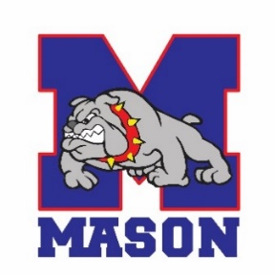

- Face coverings must be worn at all times while at the event by spectators and event staff. Athletes must wear a mask except when they are competing.
- There will be spectator limits at the meets. Updates will be available prior to the events.

