Mason Middle School
Girls Basketball
7th & 8th Grade
2021-2022

Day Date Opponent Place Time Bus Leaves

Mon. 1/24 Fowlerville 8th Away 4:30 p.m. 3:15 p.m.
7th Home

Wed. 1/26 Okemos 8th Home 4:30 p.m.
7th Away 3:30 p.m.

Mon. 1/31 Williamston 8th Away 4:30 p.m. 3:20 p.m.
7th Home

Mon. 2/7 East Lansing 8th Home 4:30 p.m.
7th Away 3:20 p.m.

Wed. 2/9 Haslett 8th Away 4:30 p.m. 3:20 p.m.
7th Home

Wed. 2/16 Portland 8th Home 4:30 p.m.
7th Away 3:10 p.m.

Mon. 2/14 Holt 8th Away 4:30 p.m. 3:30 p.m.
7th Home

Wed. 2/23 Waverly 8th Home 4:30 p.m.
7th Away 3:15 p.m.

Mon. 2/28 Haslett 8th Home 4:30 p.m.
7th Away 3:20 p.m.

Wed. 3/2 Fowlerville 8th Away 4:30 p.m. 3:15 p.m.
7th Home

Coaches: 7th grade: Kirk Petee, Head Coach
Anna Vandenbusshe, Assistant Coach
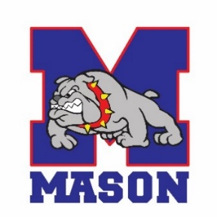
8th grade: Andy Vondra, Head Coach
Dave Dodendorf, Assistant Coach

Admission: $3.00 adult $2.00 Student

Revised 06/10/2021

